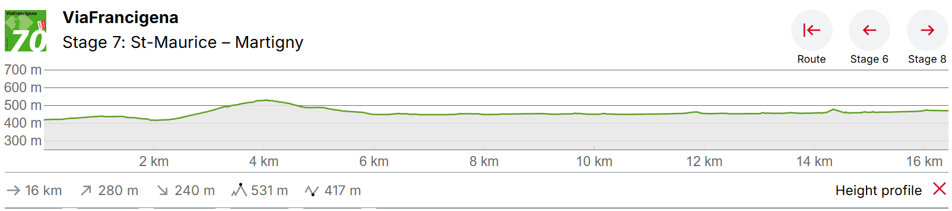
St St Maurice – Martigny

Just after St. Maurice you reach Vérolliez, where a small chapel commemorates the martyrdom of Saint Maurice and his companions. On the way to the Rhone Valley, you come across the famous Pissevache waterfall and the 200 metre-deep Trient Gorge.
At the end of the 3rd century, a Roman officer named Maurice was executed at St. Maurice for his Christian beliefs. A place of pilgrimage was then created here, and the Abbey of St. Maurice was founded by Sigismund, the King of Burgundy, in 515. The eighth stage of the Via Francigena starts at St. Maurice train station. You have to take a detour if you do not want not to miss the historic town centre and the abbey on the designated route to Martigny.
Going past residential areas, you leave the municipality and pass Vérolliez. Les Emonets and Evionnaz are next. You will then see the remains of an anti-tank embankment, consisting of “Toblerones” lined up irregularly. The prongs, reminiscent of Toblerone chocolate, served as a line of defence during World War II on the Great St. Bernard axis. A good hour later, you reach the Pissevache waterfall. Its beauty was an inspiration for Goethe, Jean-Jacques Rousseau and other poets and painters. The 116-metre-high waterfall used to be called Salanfe. The French saying, “il pleut comme vache qui pisse” (literally: it is raining like a cow pissing), is said to have inspired a passer-by to rename the waterfall. In the past, you could cross the waterfall via a footbridge halfway up. Unfortunately, this is no longer possible today.
A little later, you walk past the exit of the Trient Gorge. The source of the Valais River is at the Trient Glacier, above the village of the same name in the Swiss Mont Blanc region. An impressive 200-metre-deep gorge has been carved out here. It is spanned by two bridges at a dizzying height, and you can admire the 114-metre-high waterfall from here. This is followed by the last hour of the hike to Martigny, and you cross the Dranse shortly before the finish. La Bâtiaz Castle sits proudly on a rock slightly above the river. Martigny is located on the Rhone bend in the Lower Valais. It is the hub of the pass routes via Simplon, Great St. Bernard and Forclaz.

Accommodation Martigny
Gîte Accueil pèlerins, Prieuré
secretariat@paroissemartigny.ch
5 beds only – no reservations – 1st come from 1400 onwards – 20 CHF free breakfast with the community
Nous accueillons effectivement dans notre Paroisse les pèlerins de la Via Francigena, ceci pour une nuit. Nous avons au Prieuré (rue de l’Hôtel-de-Ville 5) un petit dortoir comprenant 5 lits, avec WC et douche à disposition. La nuitée coûte CHF 20.00 et le petit-déjeuner, si vous voulez le prendre avec la Communauté, est gratuit. Etant donné que notre « espace pèlerins » se trouve en plein centre de la ville, il n’y a pas de problème pour trouver des restaurants ou des magasins d’alimentation. Toutefois, nous ne prenons aucune réservation. Les premiers arrivés seront les premiers servis. Vous pouvez spontanément vous présenter au Prieuré, dès 14h, et demander à être hébergés. Si le Prieuré est fermé et que personne ne répond, vous pouvez vous adresser à la Maison St-Bernard (grand bâtiment en face, aux volets verts)
Rue de l'Hôtel de Ville 5, 1920, Martigny, Switzerland

Auberge de Jeunesse Martigny
Rue du Bourg 35, 1920 Martigny
46CHF PPPN (bed in large mixed dorm)

Hotel de la post
Rue de la Poste 8, 1920 Martigny, Switzerland c. 35CHF PPPN
- 19 chambres twins (avec 2 lits séparés)
- 12 chambres simples
- 6 chambres doubles (avec un grand lit)
- 2 chambres triples

Hotel Du Stand
Av. du Grand-Saint-Bernard 41, 1920 Martigny, Switzerland c.40CHF PPPN – checking availability

